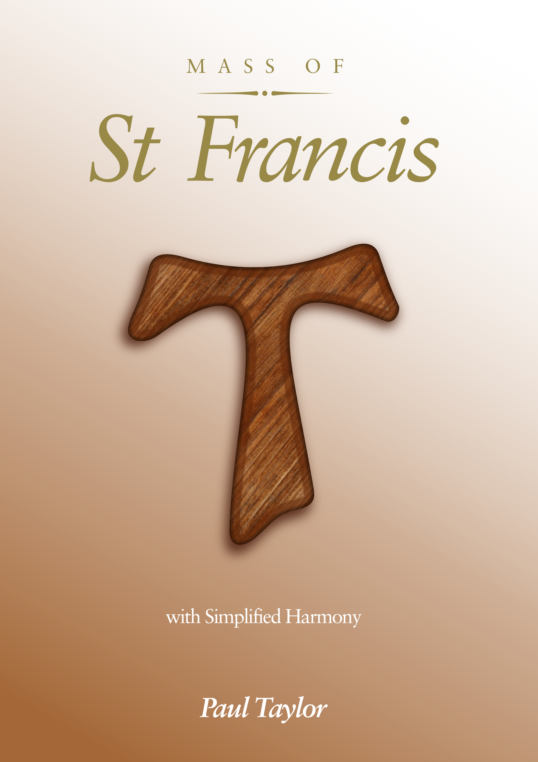MASS OF

*St Francis*